**SnapPaint – The Online Selfie Editor**

The project we had in mind is SnapPaint, a webcam camera that can take photos, and modify them with our integrated tools.

Here are some possible features that we will try to make work:

* A webcam camera with the ability to take a picture using html video to set up the dimensions and properties of the camera, and a button that will take the picture using mouse click events. This image will be captured then a continue button will load the picture into a new page containing the canvas.
* The ability to store that image on HTML canvas and draw on top of it using SnapPaint’s drawing tools, similar to Lab 12, and also generate text on the image using canvas. The text will be generated using a keyboard input event.
* The ability to add filters on the image by 50% transparent images of photo filters that will overlay the photo using canvas. The filter image will be loaded onto canvas, and since it will be translucent, it will overlay on top of the image and produce a filter effect.

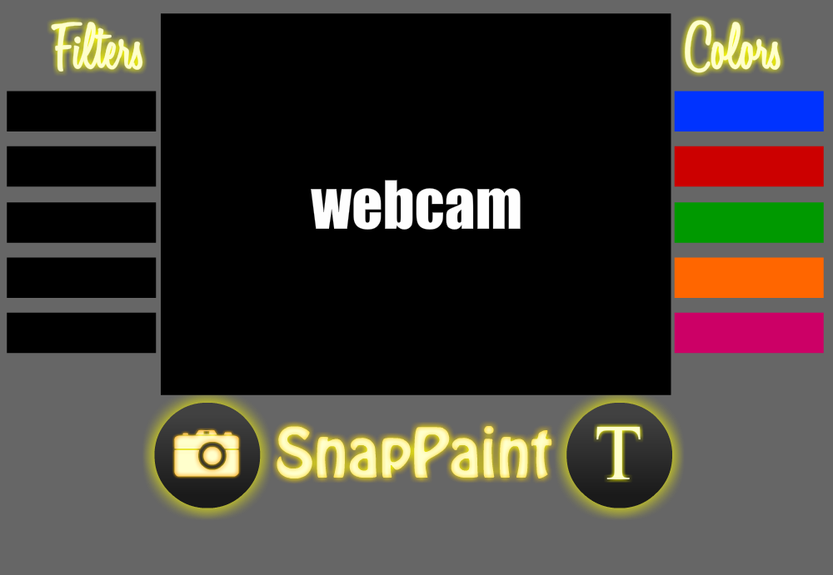

Above is the planned user interface design. This design will be done using CSS. There will be a few options for colors to draw on canvas as well as filters to overlay on image. Below the camera is the capture image button and text input button.